Remedial BBAP (Behavior Based Amazon Pay) Implementation Guide

1. Introduction
This document explains how you can implement BBAP to your e-commerce site.

2. Prerequisite
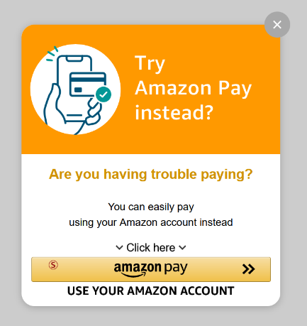
Please confirm you have required files listed below.
- remedial_bbap_sample.html
- amazonpayAssist_en.js

3. How to implement Remedial BBAP
3-1. Put 2 files in prerequisite section in same local folder and double-click HTML file. You can see Remedial BBAP popup screen on the page.
(Please don’t click Amazon Pay button since we haven’t configured correct Amazon Seller Account related configurations yet.)

3-2. You can change background color here. (Default Color is ‘Orange’.)
Available Color Type: 'Green', 'Blue', 'Orange', 'LightGreen', 'LightBlue', 'LightOrange'
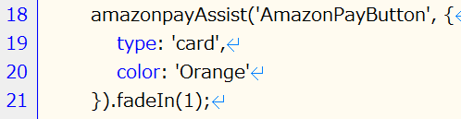

3-3. Please update Amazon Seller Account related configurations (especially red square part).
(This is same as standard Amazon Pay integration. Check developer guide for further details. Please don’t change placement: ‘Home’. In addition, this integration is Amazon Pay APB integration. If you need to change the integration, please check developer guide.)
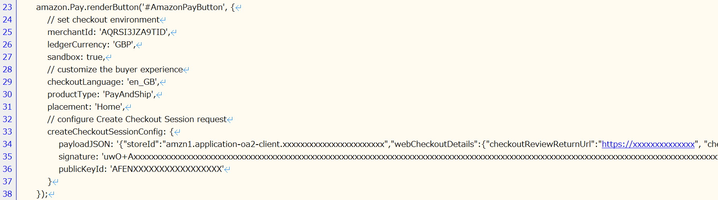

3-4. If implementation works fine with your Amazon Seller Account, add this integration to your e-commerce site.

