**Remedial BBAP (Behavior Based Amazon Pay) Implementation Guide**

**1. Introduction**

This document explains how you can implement BBAP to your e-commerce site.

**2. Prerequisite**

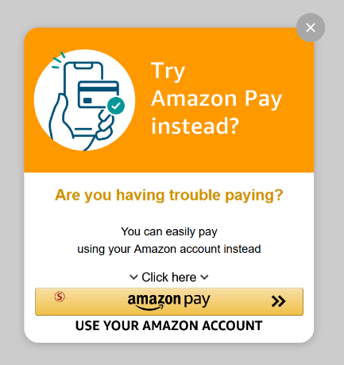Please confirm you have required files listed below.

* remedial_bbap_sample.html
* amazonpayAssist_en.js

**3. How to implement Remedial BBAP**

3-1. Put 2 files in prerequisite section in same local folder and double-click HTML file. You can see Remedial BBAP popup screen on the page.

(Please don’t click Amazon Pay button since we haven’t configured correct Amazon Seller Account related configurations yet.)

3-2. You can change background color here. (Default Color is ‘Orange’.)

Available Color Type: 'Green', 'Blue', 'Orange', 'LightGreen', 'LightBlue', 'LightOrange'

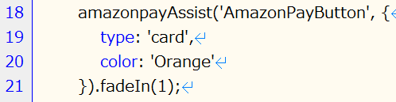

3-3. Please update Amazon Seller Account related configurations (especially red square part).

(This is same as standard Amazon Pay integration. Check [developer guide](https://developer.amazon.com/docs/amazon-pay-apb-checkout/add-the-amazon-pay-button.html) for further details. Please don’t change placement: ‘Home’. In addition, this integration is Amazon Pay APB integration. If you need to change the integration, please check developer guide.)

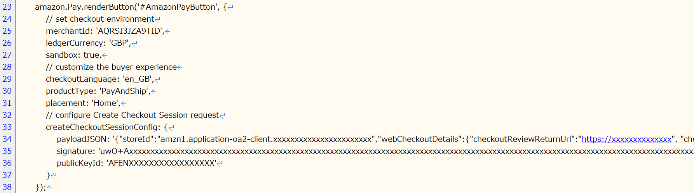

3-4. If implementation works fine with your Amazon Seller Account, add this integration to your e-commerce site.